Irish Soda Bread with Caraway Seeds
by Heather Gibson
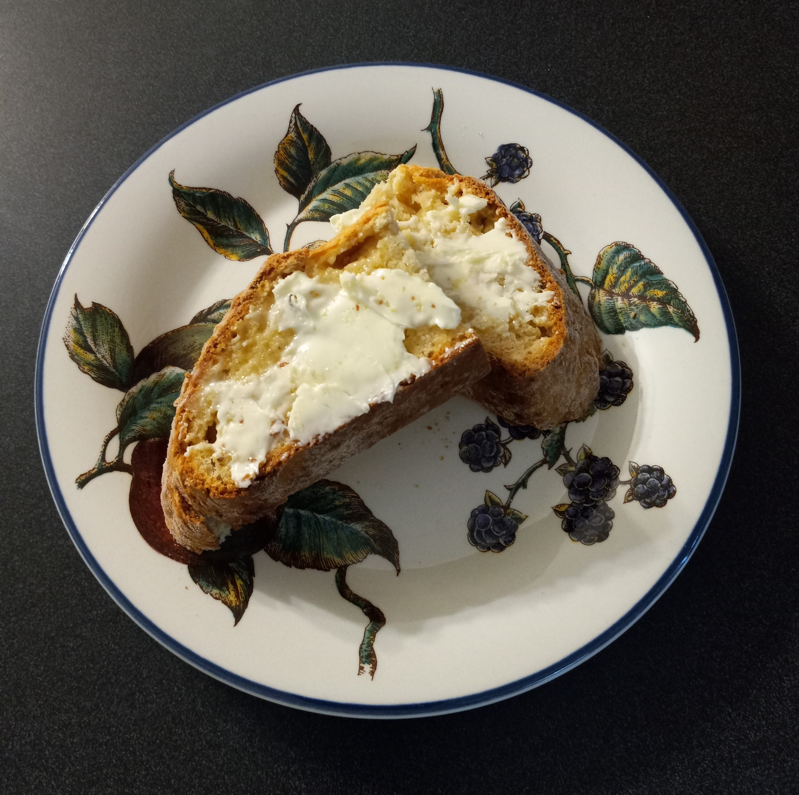

3 ½ c all-purpose flour
⅓ c granulated sugar (I used raw)
2 t caraway seeds
1 t salt
1 t baking soda
4 T cool butter, cut into 8 pieces***
1 ½ c buttermilk

Preheat oven to 400° F. Line a rimmed baking sheet with parchment paper.

Whisk together flour, sugar, caraway seeds, salt, and baking soda in a large bowl. Cut in the cool butter with either your fingers or a pastry cutter until no large pieces remain. If you use your fingers, work the butter into the flour in a snapping motion.

Add the buttermilk and gently stir until all the liquid is absorbed. This dough is very sticky, so lightly dust with flour and continue stirring until it is manageable.
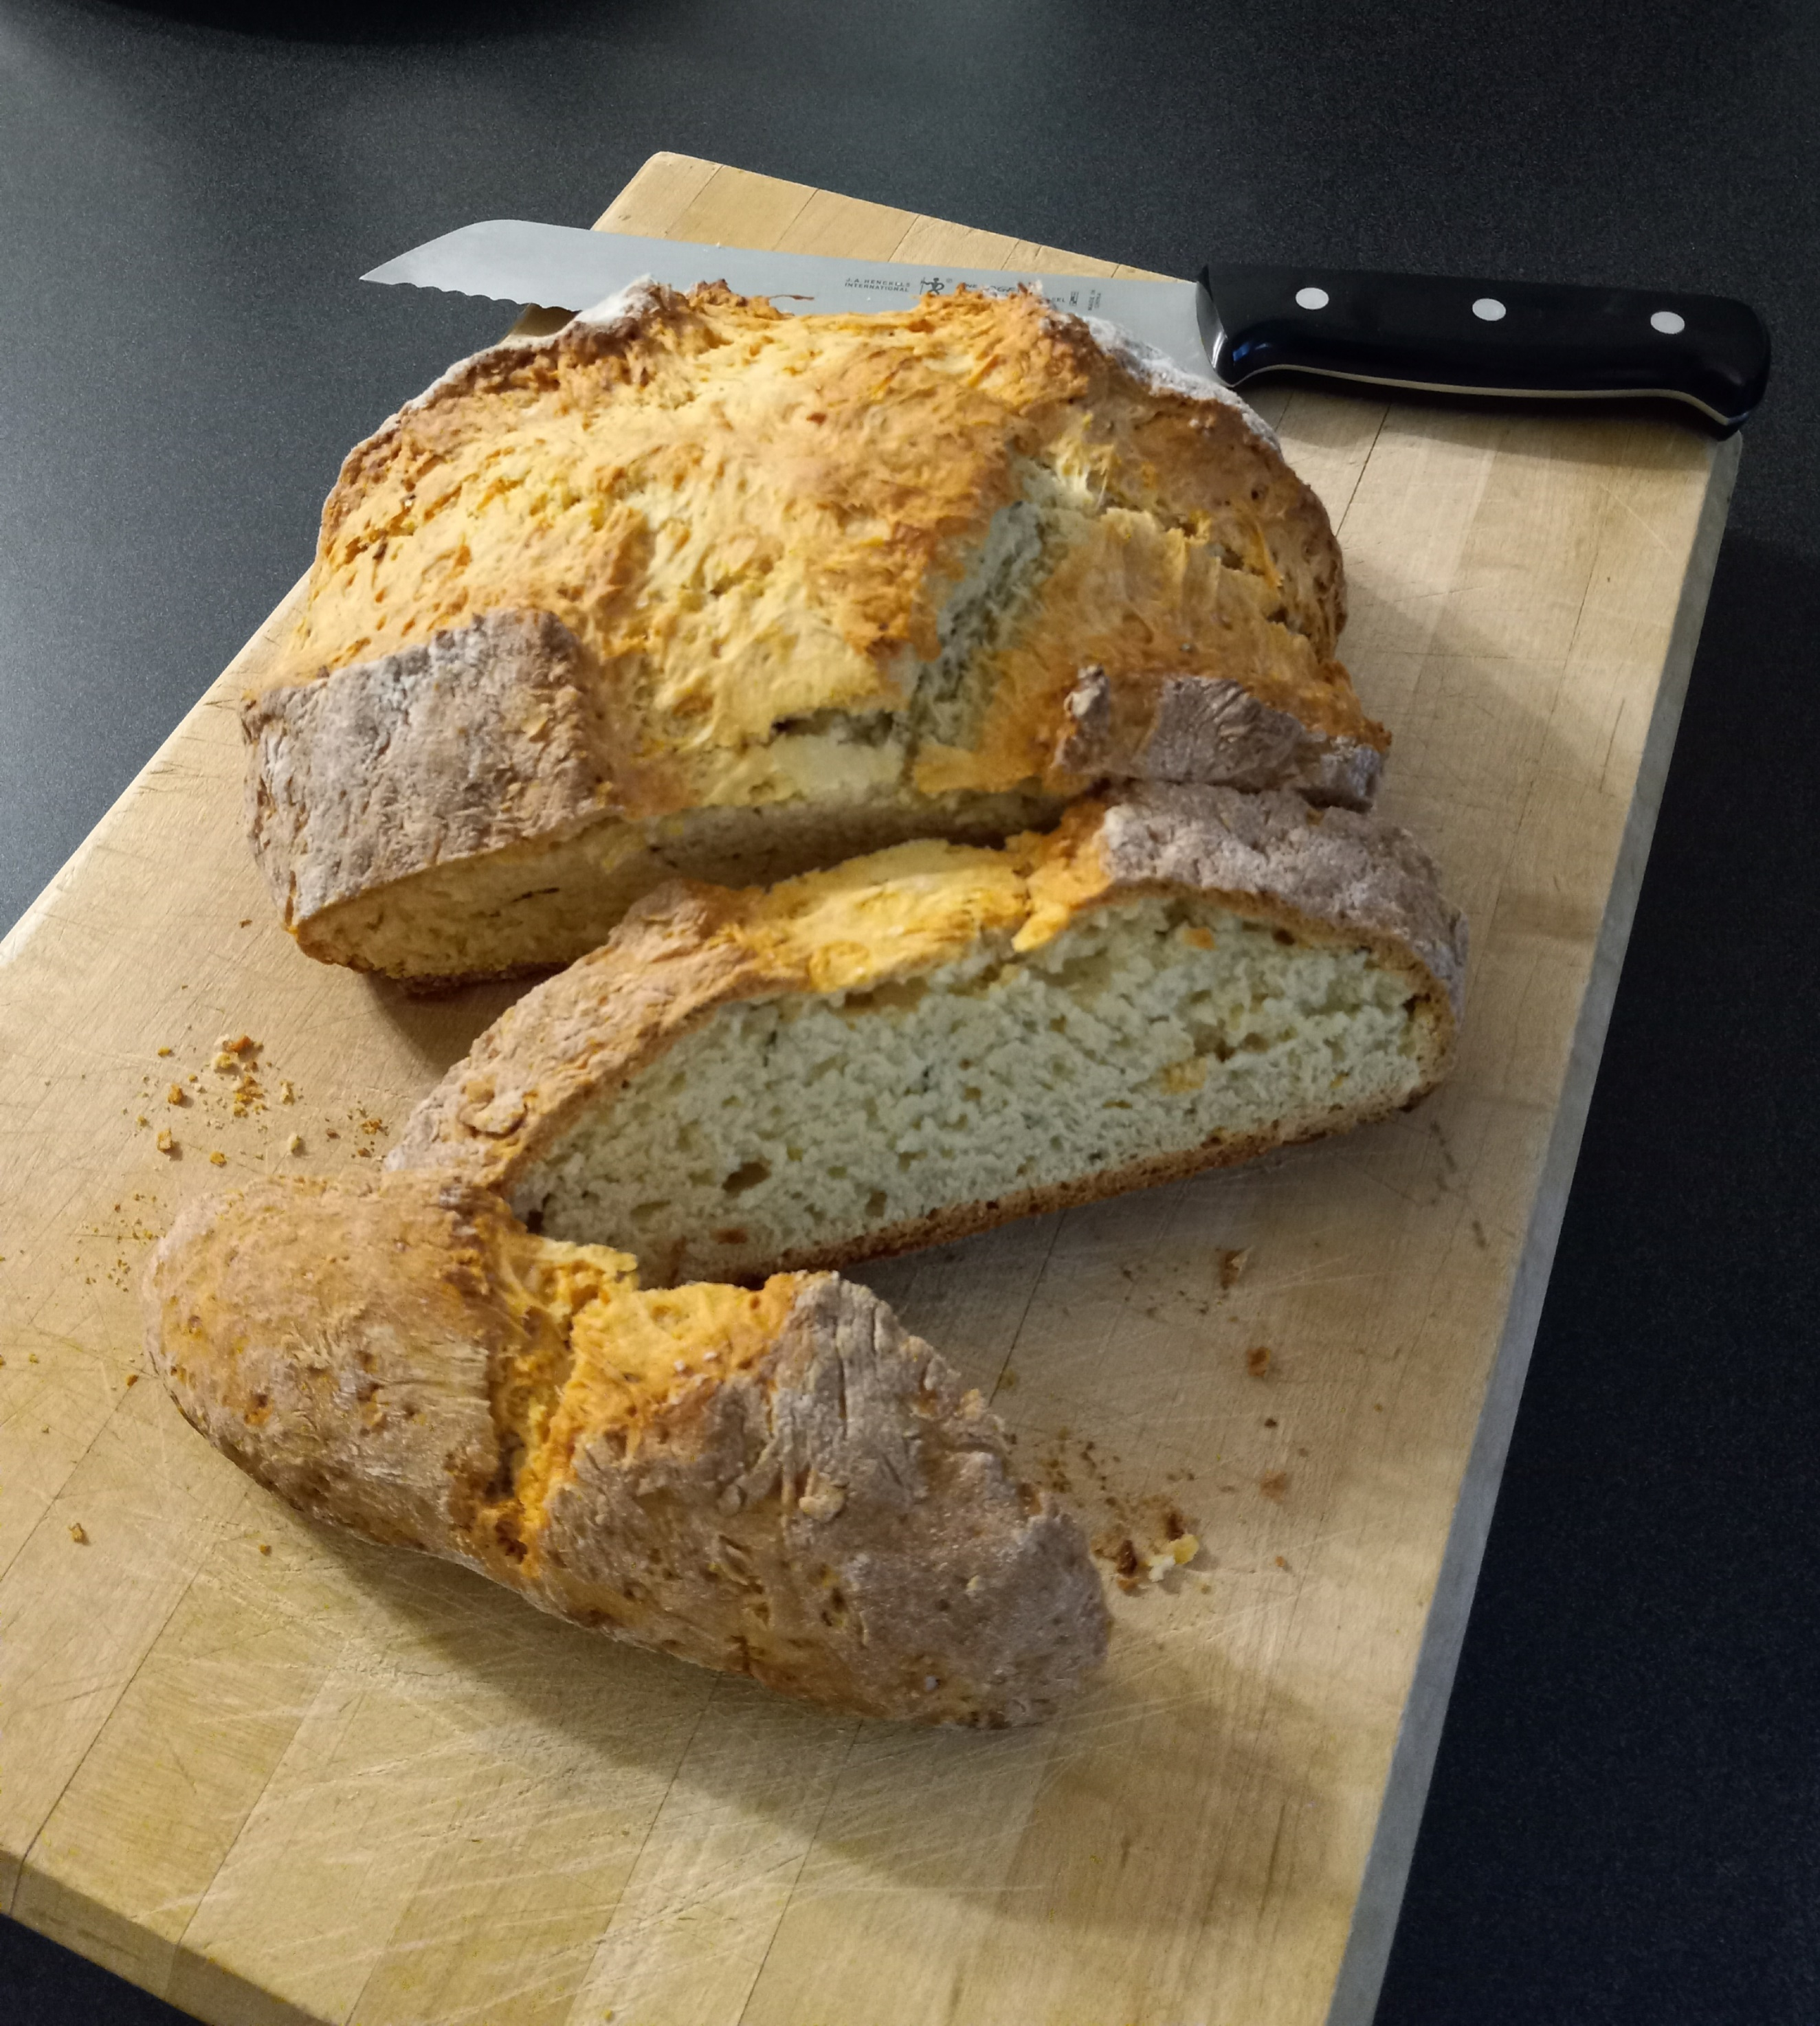
Dust the counter lightly with flour and turn the dough out onto the counter. Knead until a dough ball forms. If the dough is still sticky, add more flour about a tablespoon at a time and knead gently until it no longer sticks to your hands or kneading surface. Your dough ball should be light and tender but hold its shape.

Place dough on baking sheet. Cut a cross, about one inch deep, into dough with a sharp knife. This helps the loaf to bake evenly.

Bake until a skewer inserted into the middle of the loaf comes out clean, about 42 – 45 minutes. If the loaf browns too quickly before the center is done, cover the loaf with foil and bake until the center is done.

Remove baking sheet from oven. Allow loaf to cool on the pan for 10 minutes before transferring to a wire rack to cool for an additional 15 minutes. Serve warm or at room temperature.

***To tell if the butter is the correct temperature, your finger should make a depression with a little pressure. If it sinks right in, the butter is too soft. If the butter feels like a piece of wood, it’s too cold.

